24-6-2015

Mike Rooijackers, Noor van Oekel, Jordi Knol, Maaike Jansen, Tim Hermens

Group E

Final GUI screens

PTS6

Table of Contents

Introduction 2

Shared GUI screens 3

Login 3

Register 3

Module D: HTML client for participants 4

My information 4

My team 4

Newsfeed 5

Assignment description 5

Code files 6

Compiling 6

Testing 7

Javadoc 8

Hints 8

Turn in 9

Module E: HTML admin console 10

Manage participants 10

Register participants 10

Manage team 11

Register team 11

Manage current game 12

Manage current round 13

Servers 13

Module F: HTML client for spectators 14

Homepage 14

Scores 15

Teams 15

Newsfeed 16

Rounds 16

Assignment 17

Competition 17

# Introduction

This document contains screenshots of the final GUI screens. The screenshots are for the HTML clients for participants (competitors), administrators and spectators. Module D and E are similar in style and layout, whereas module F has a slightly different style.

These screens are based on the GUI screen designs from the following documents:

* Global GUI designs module D
* Global GUI designs module E
* Global GUI designs module F

The final screens aren’t completely the same as the GUI screen designs, but the project team has tried to stick to the designs as much as possible. However, some changes have been made in terms of lay-out and the data that is displayed on each of the web pages.

# Shared GUI screens

The following screens are used in both module D and module E. Before you can use these modules, authentication is required.

## Login

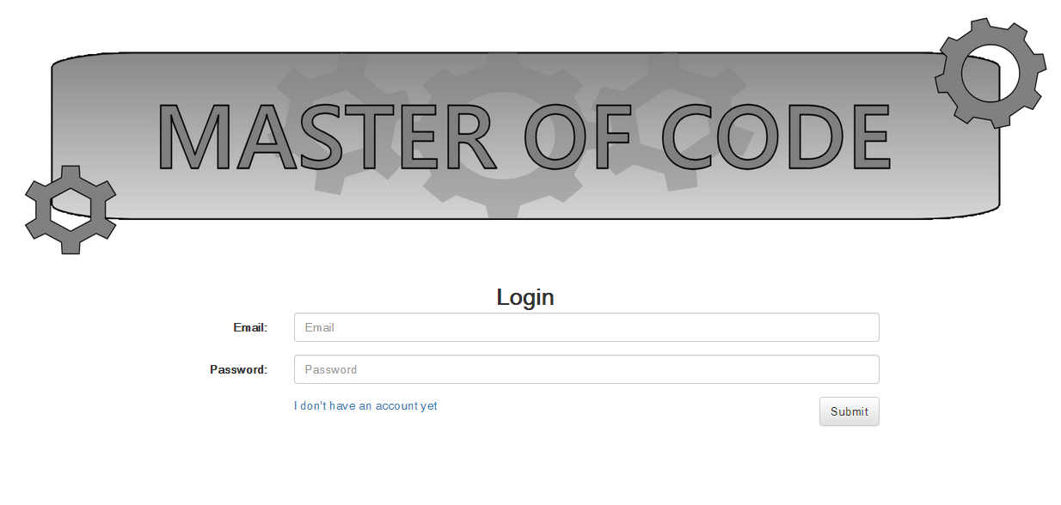

## Register

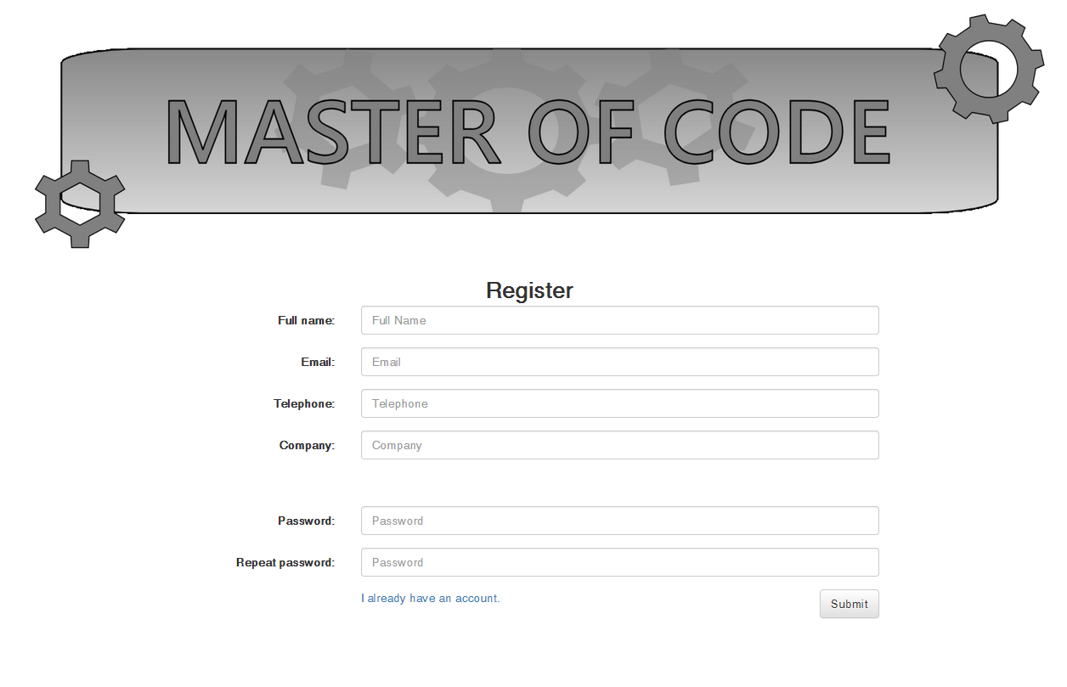

# Module D: HTML client for participants

## My information

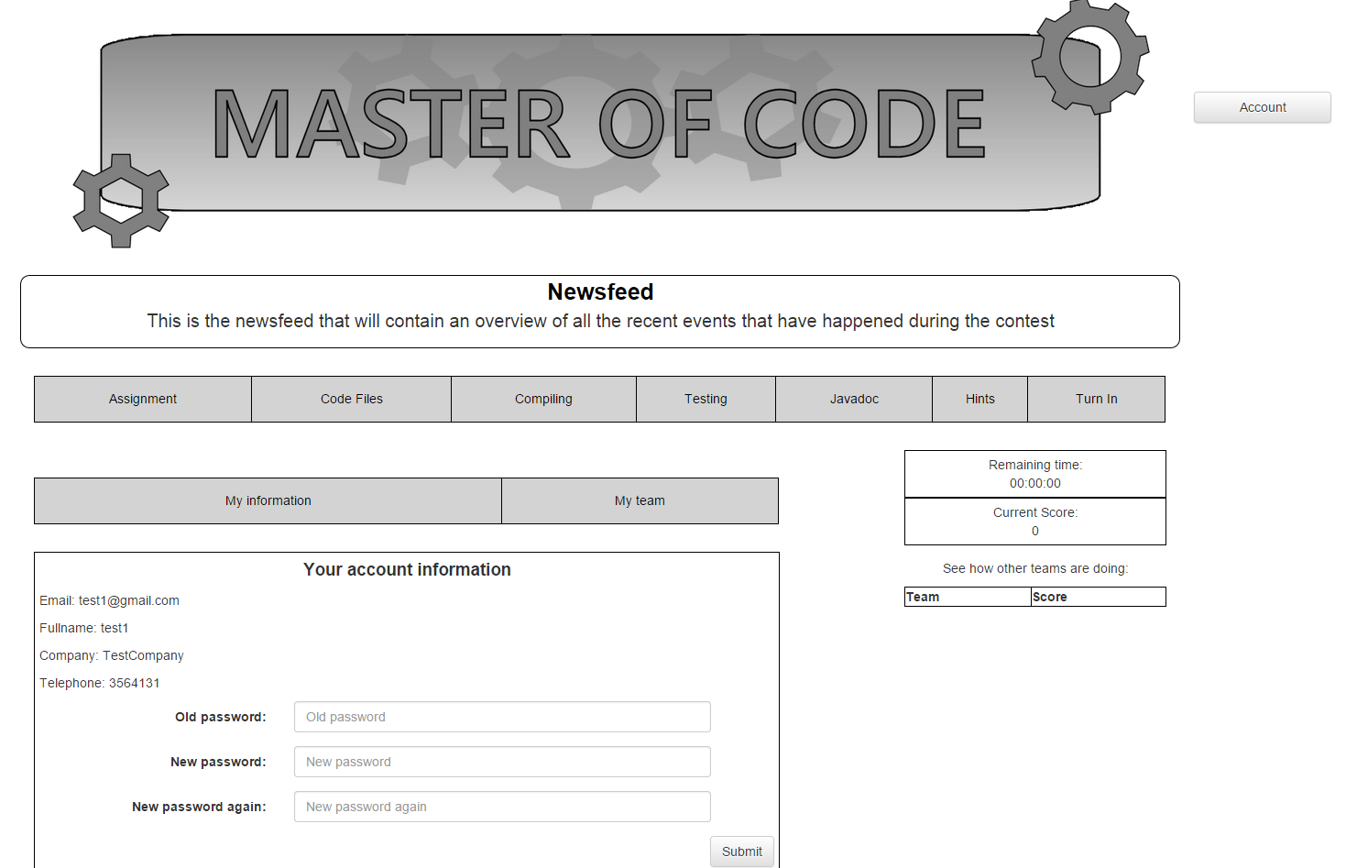

## My team

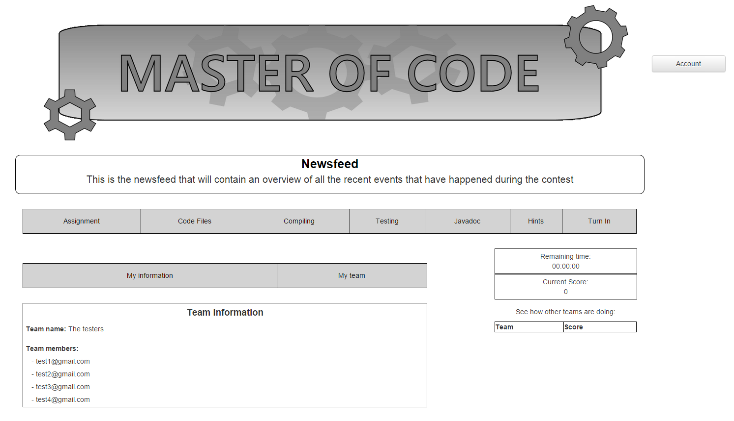

## Newsfeed

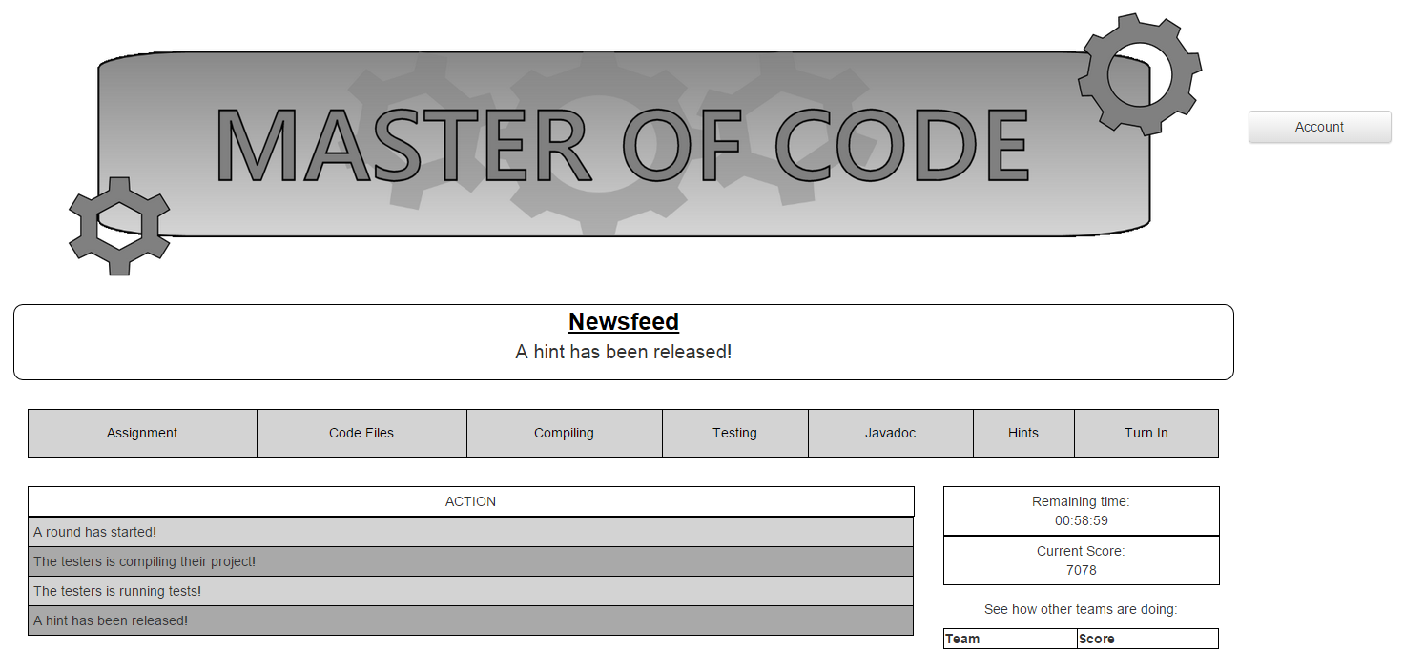

## Assignment description

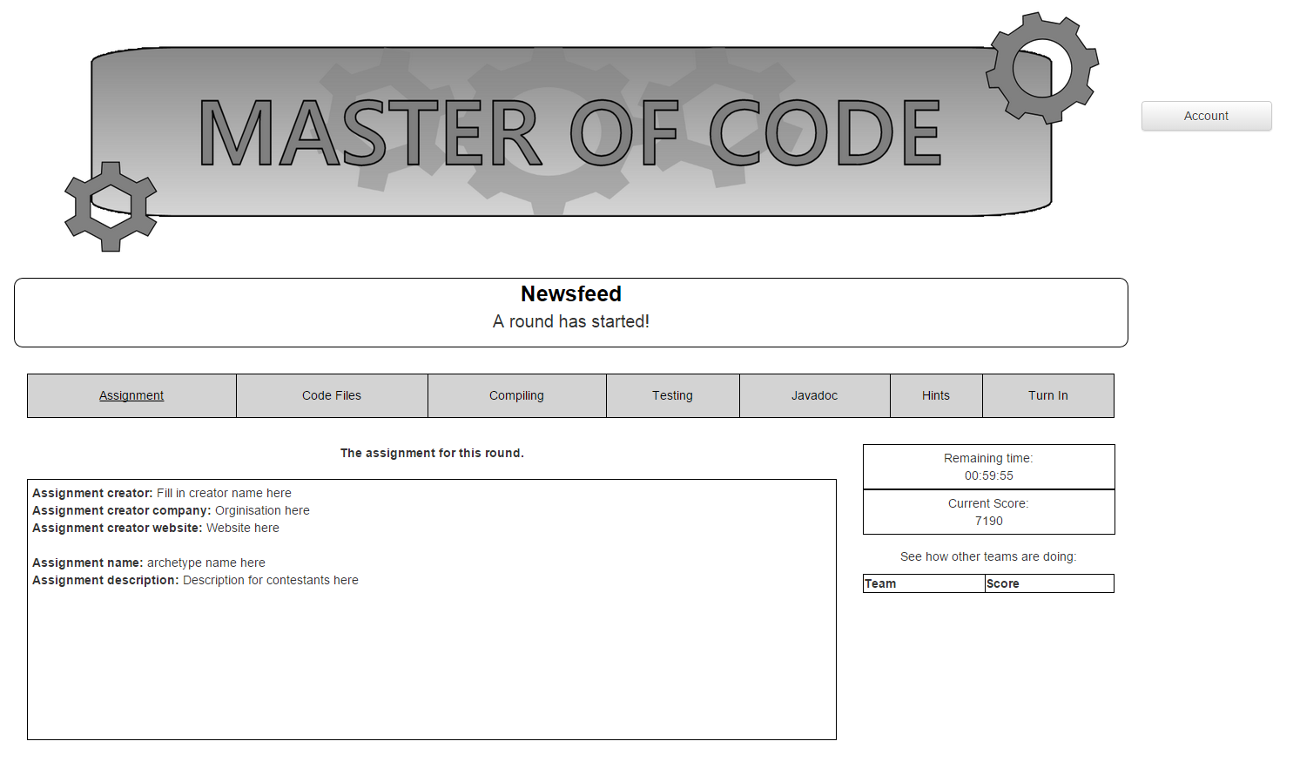

## Code files

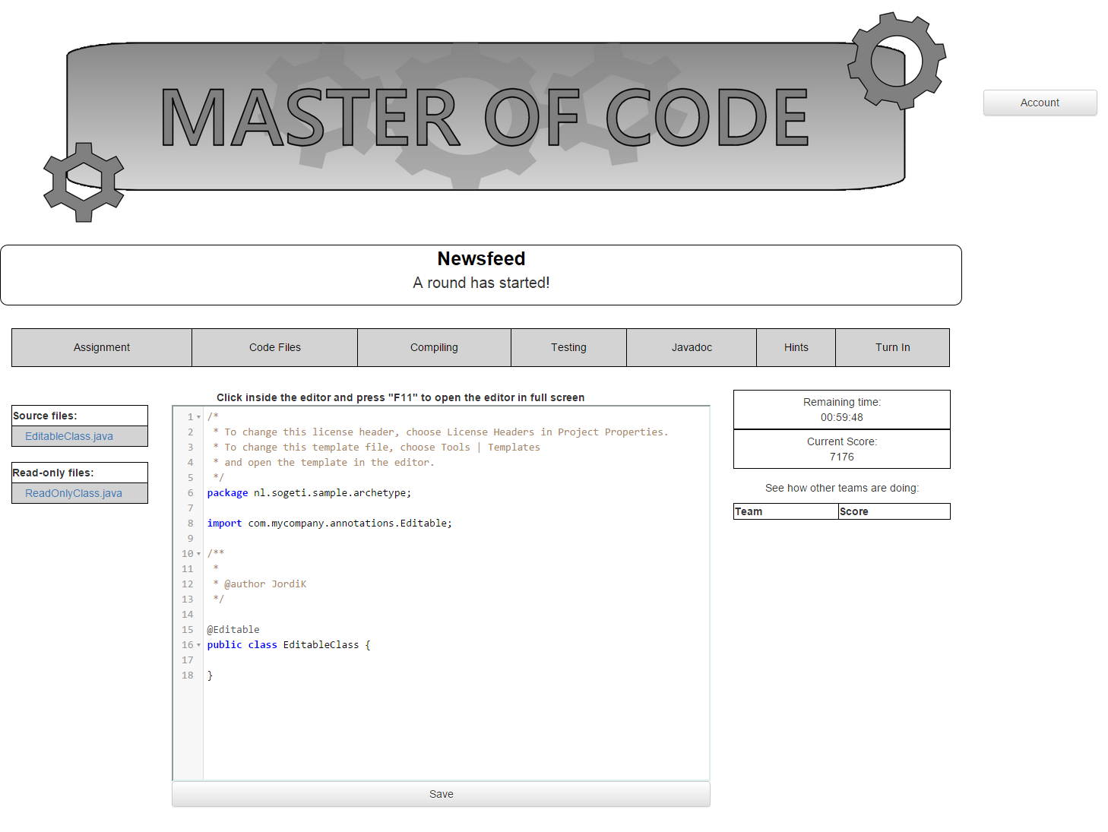

## Compiling

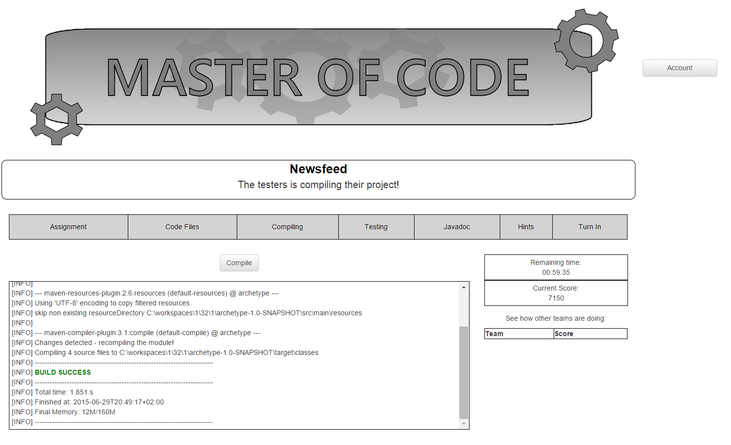

## Testing

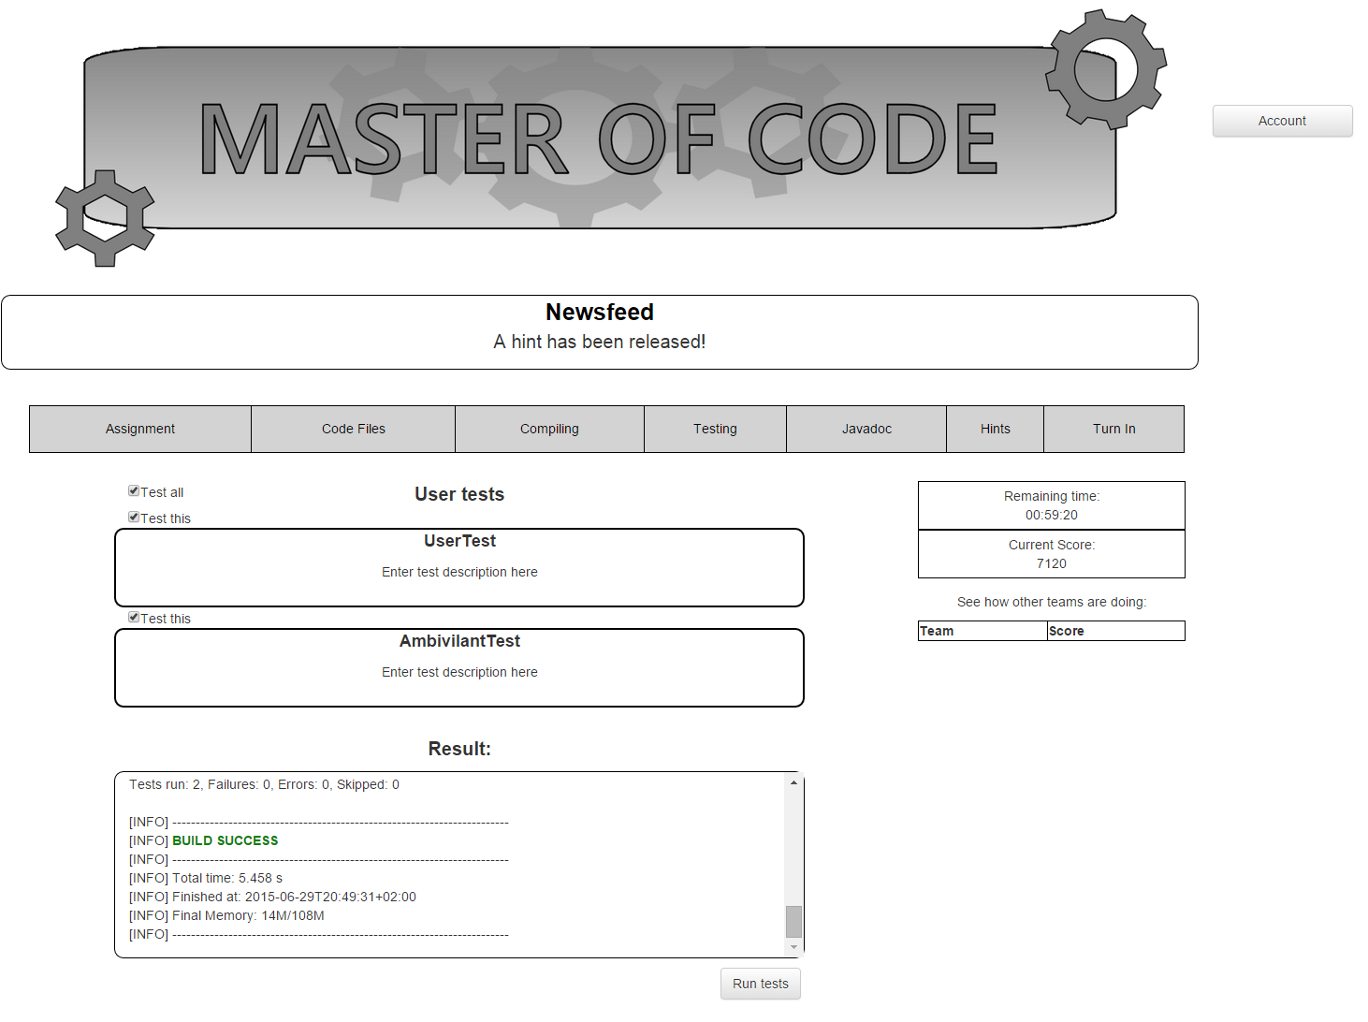

## Javadoc

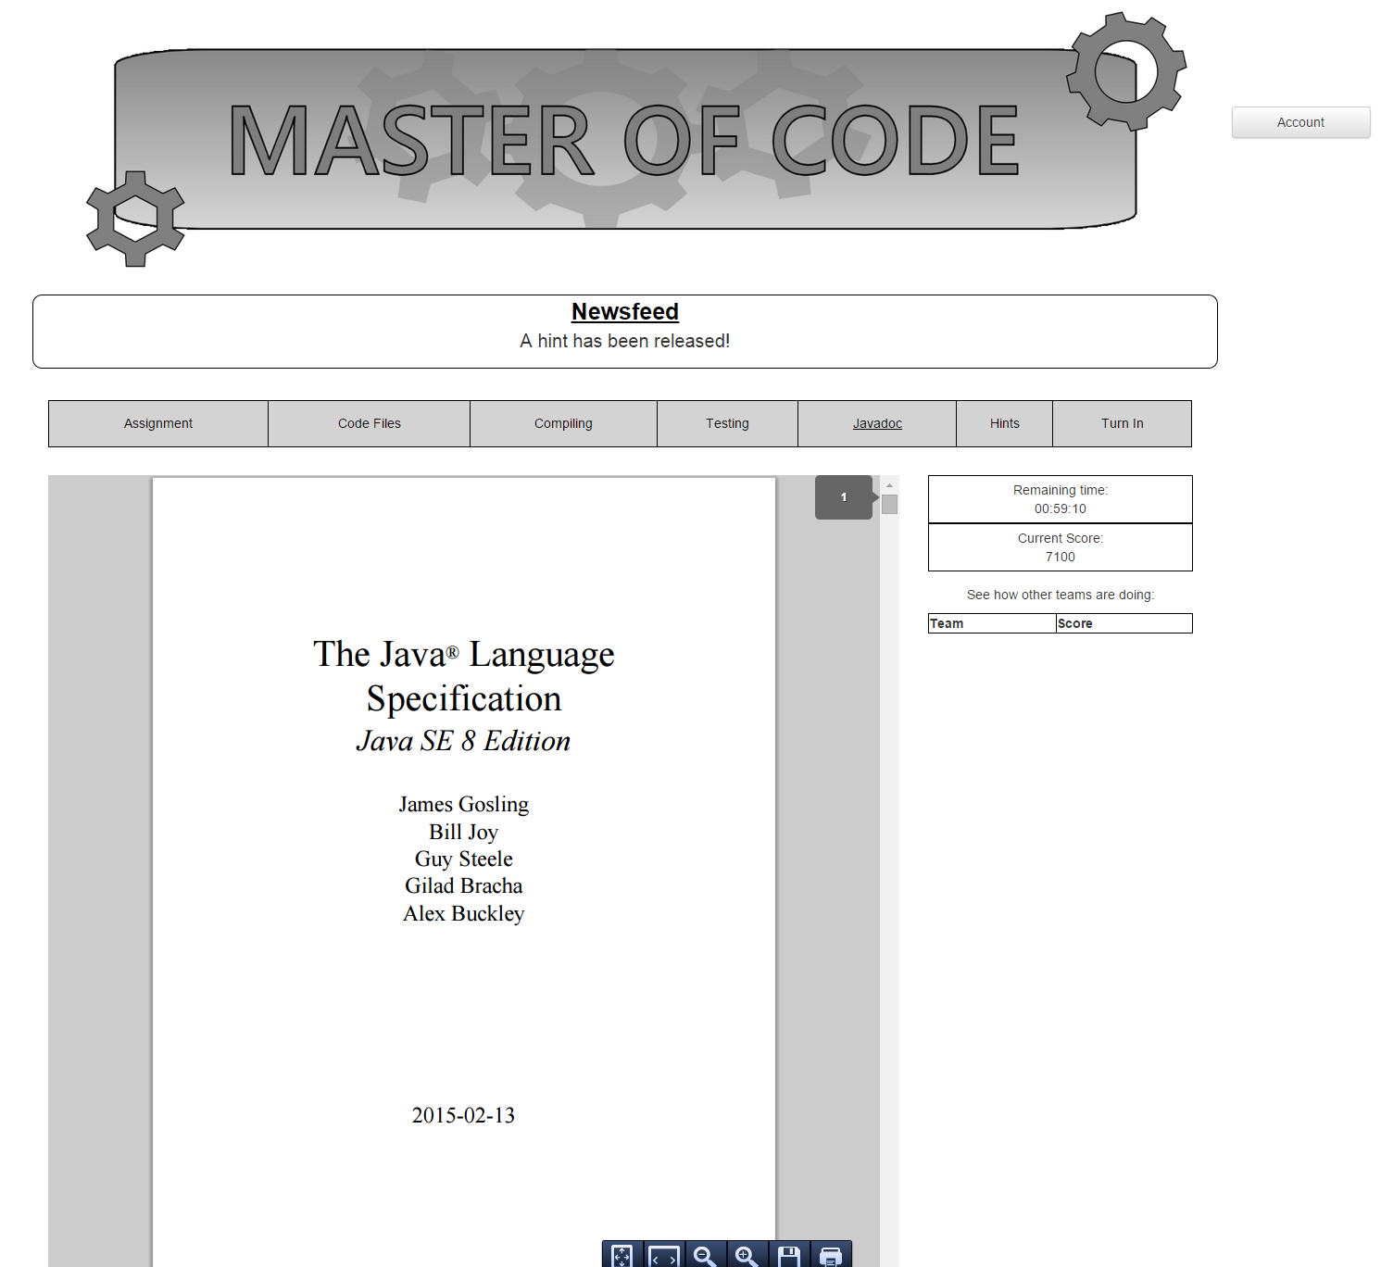

## Hints

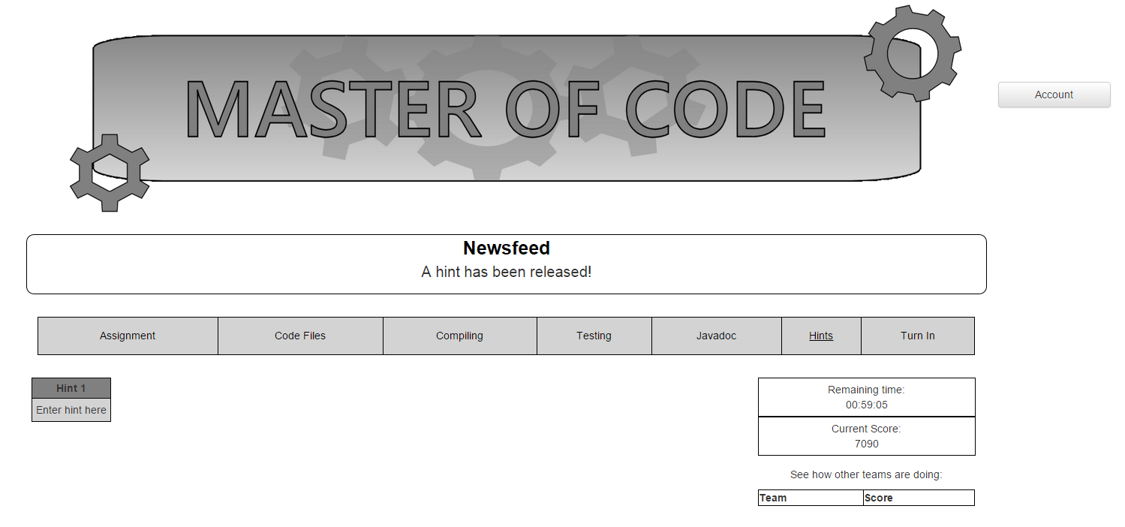

## Turn in

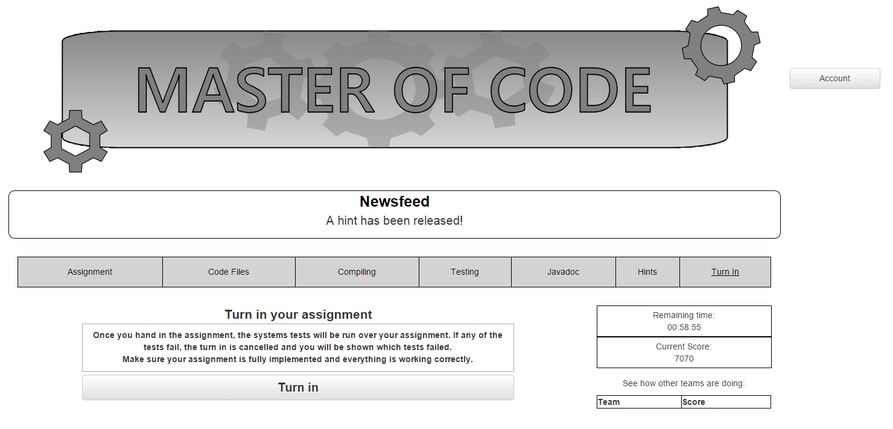

# Module E: HTML admin console

## Manage participants

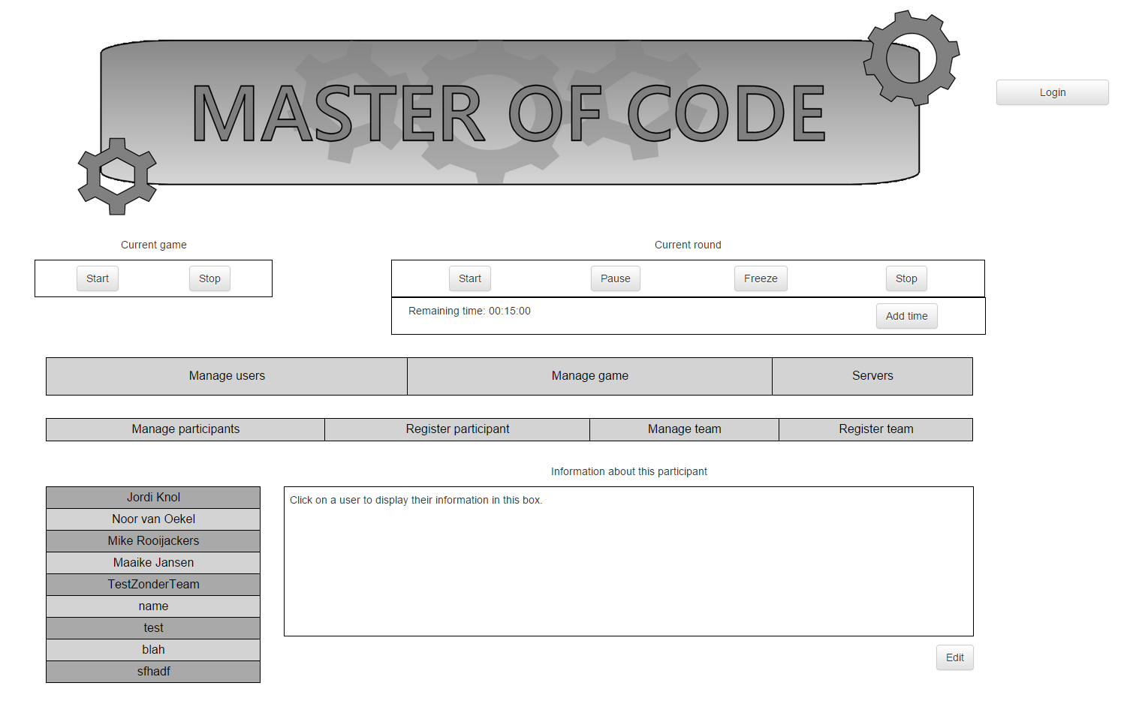

## Register participants

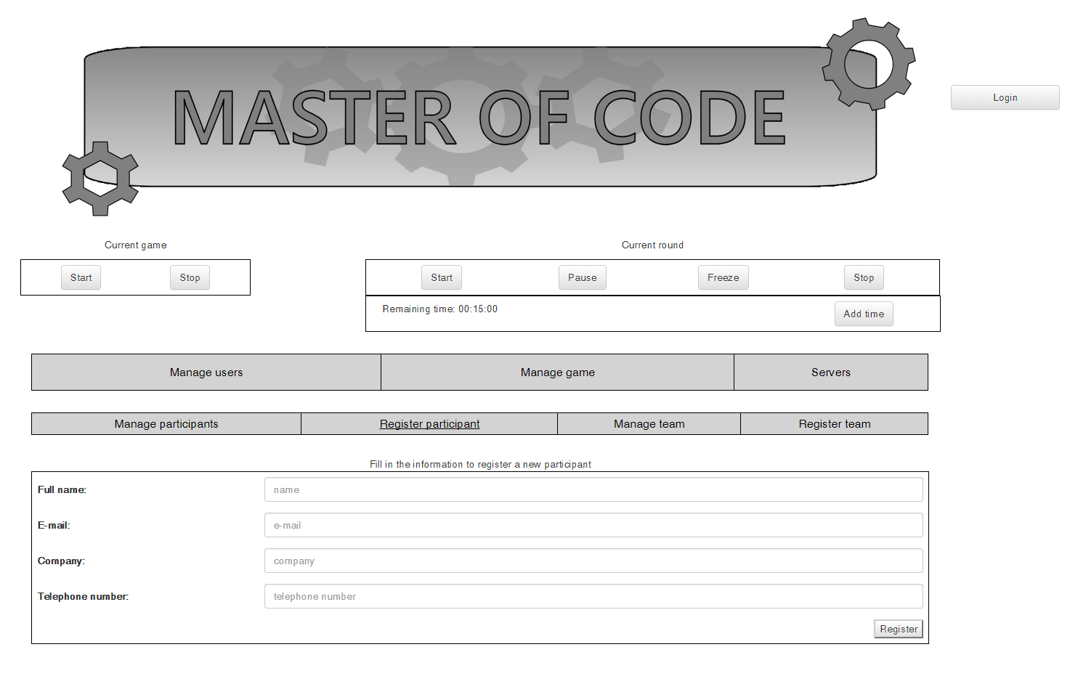

## Manage team

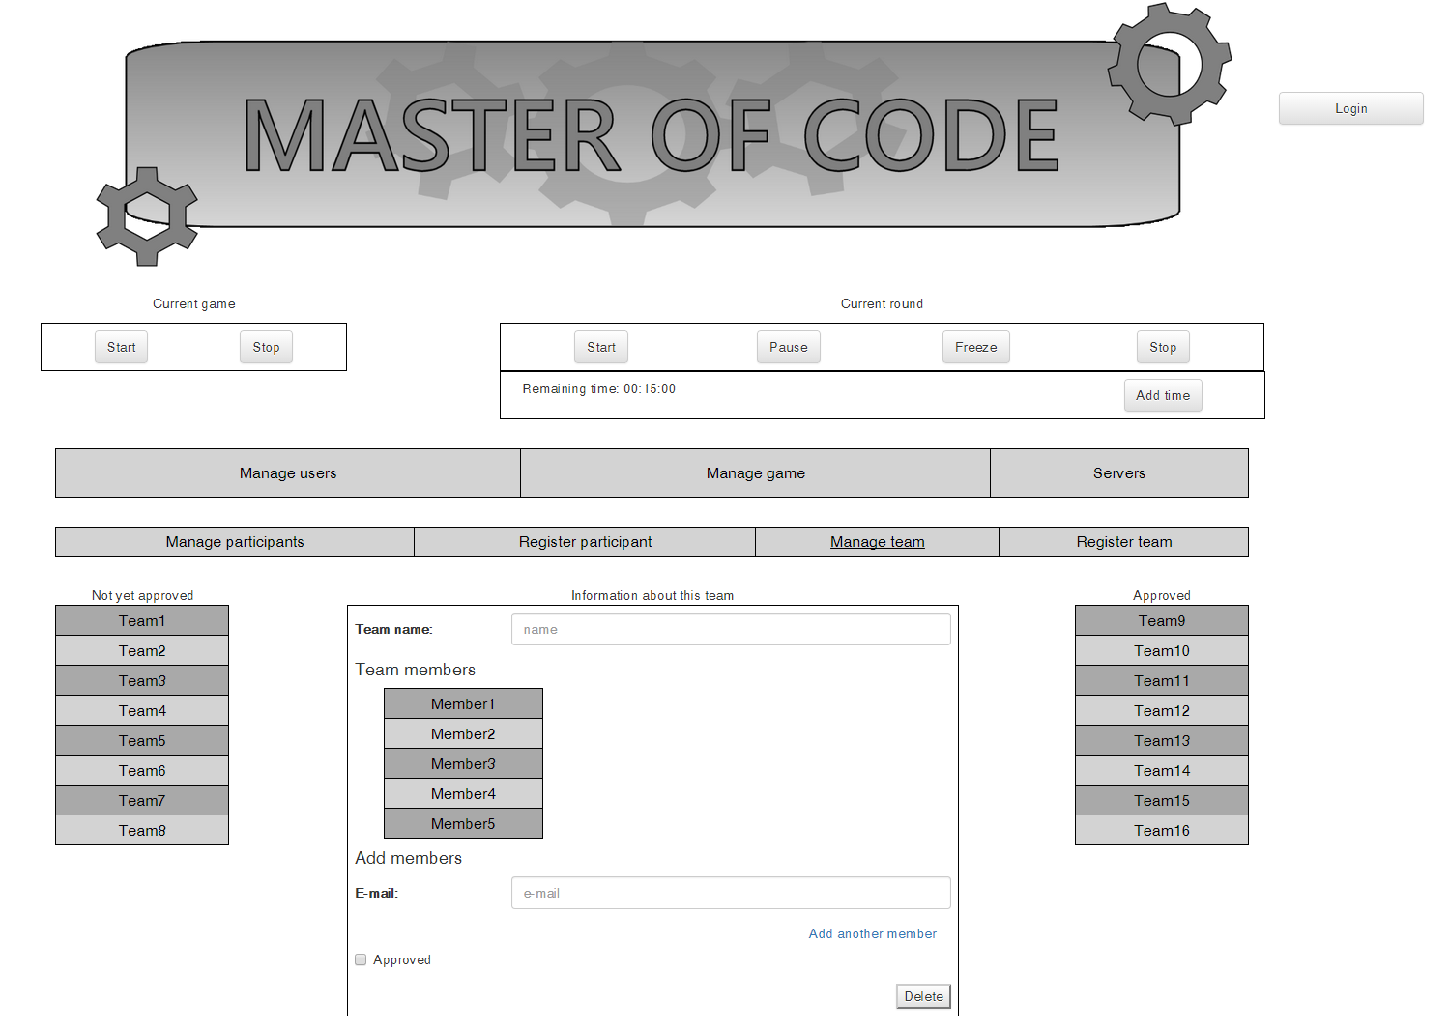

## Register team

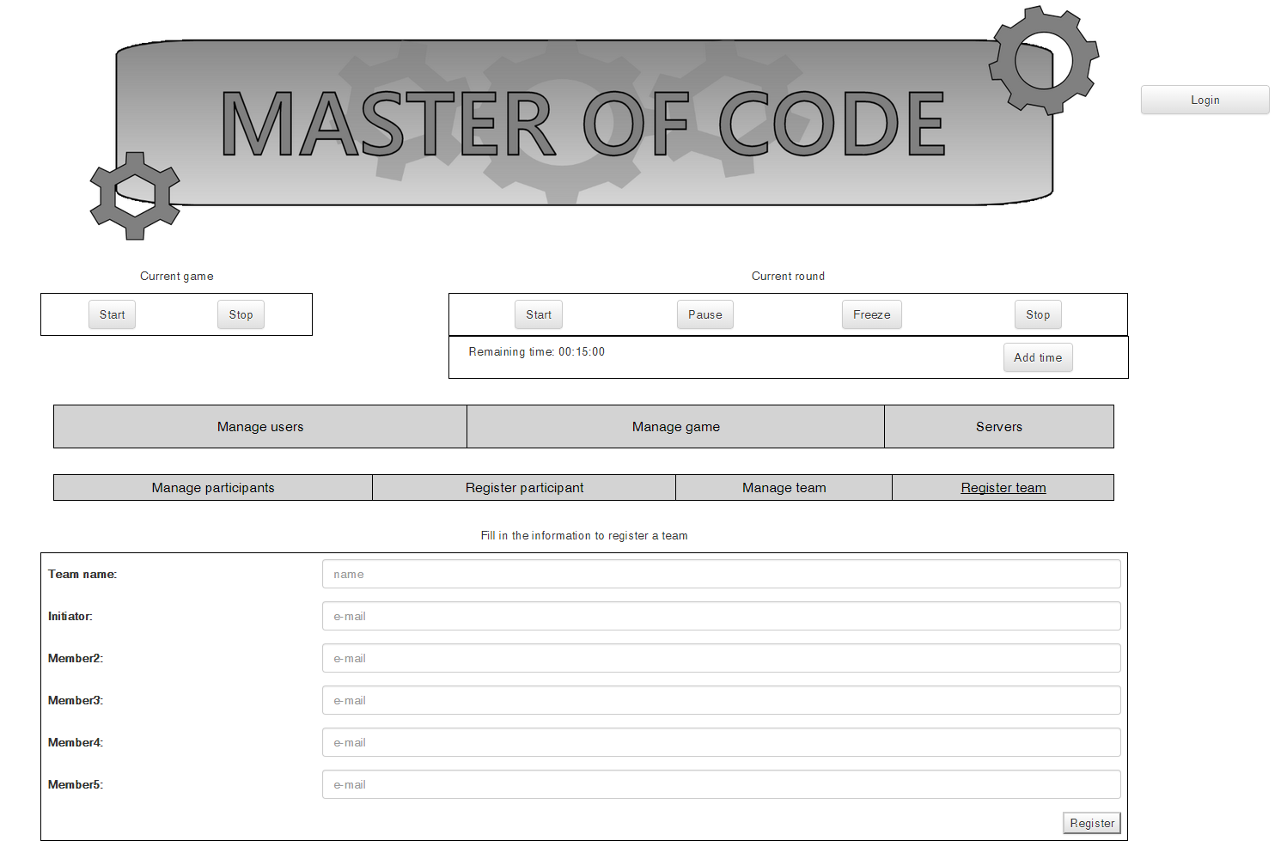

## Manage current game

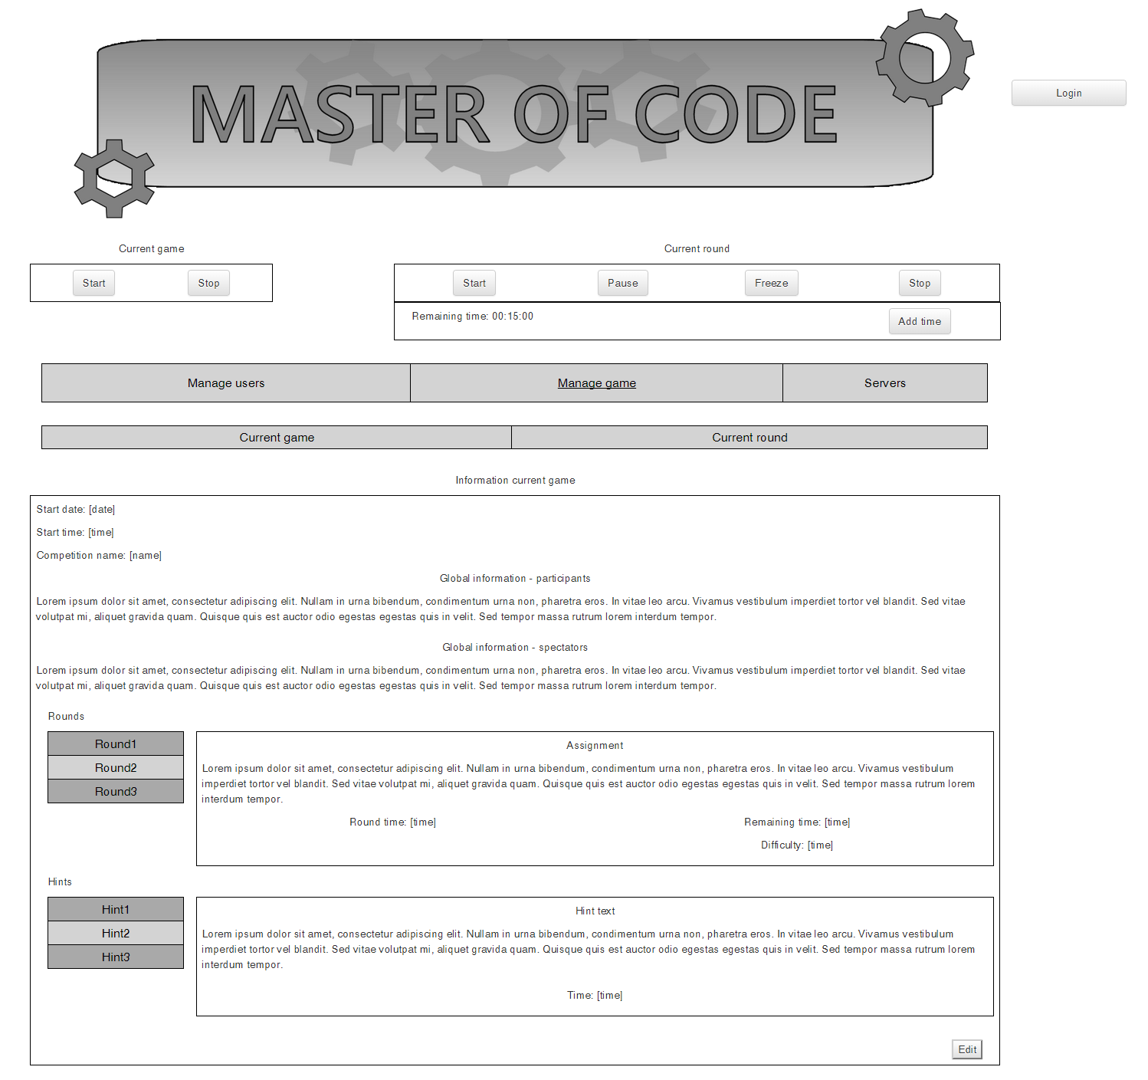

## Manage current round

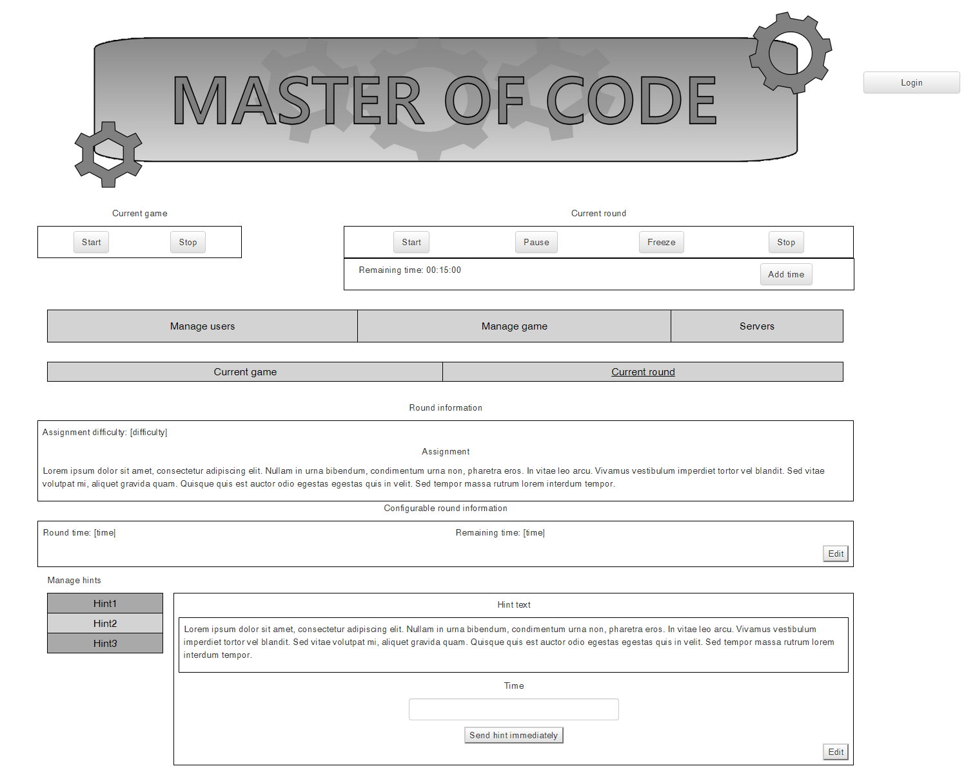

## Servers

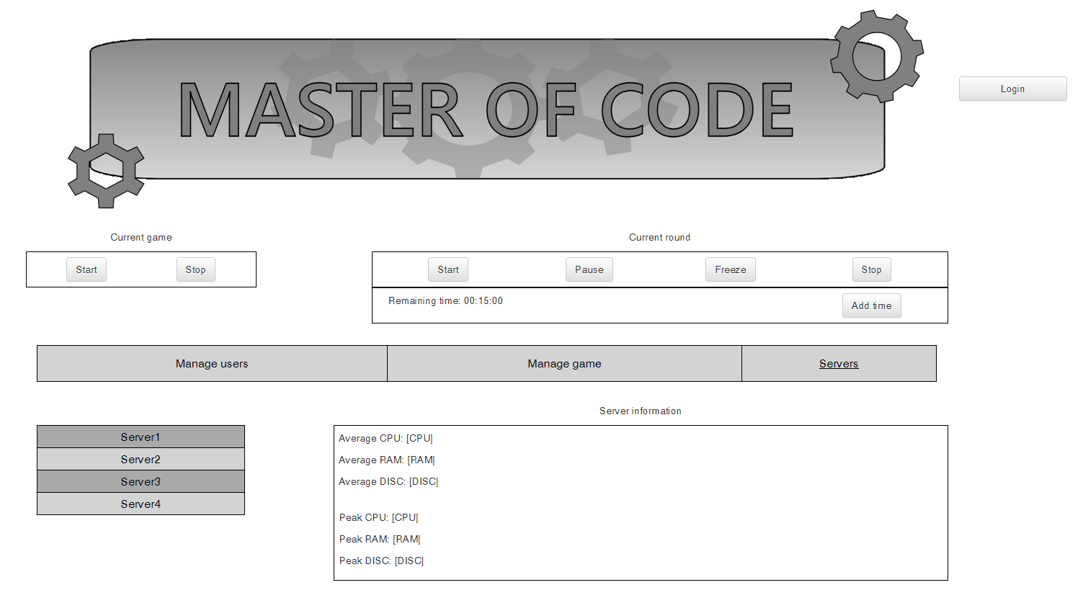

# Module F: HTML client for spectators

## Homepage

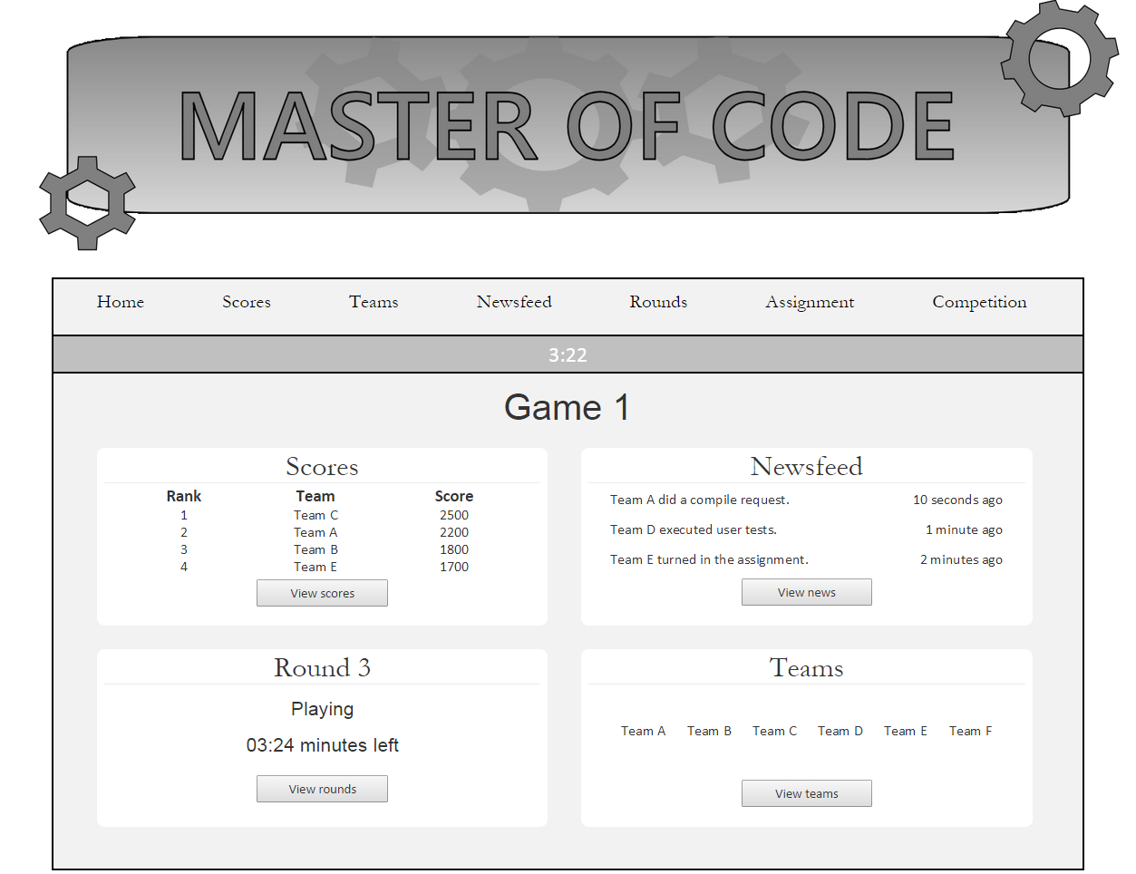

## Scores

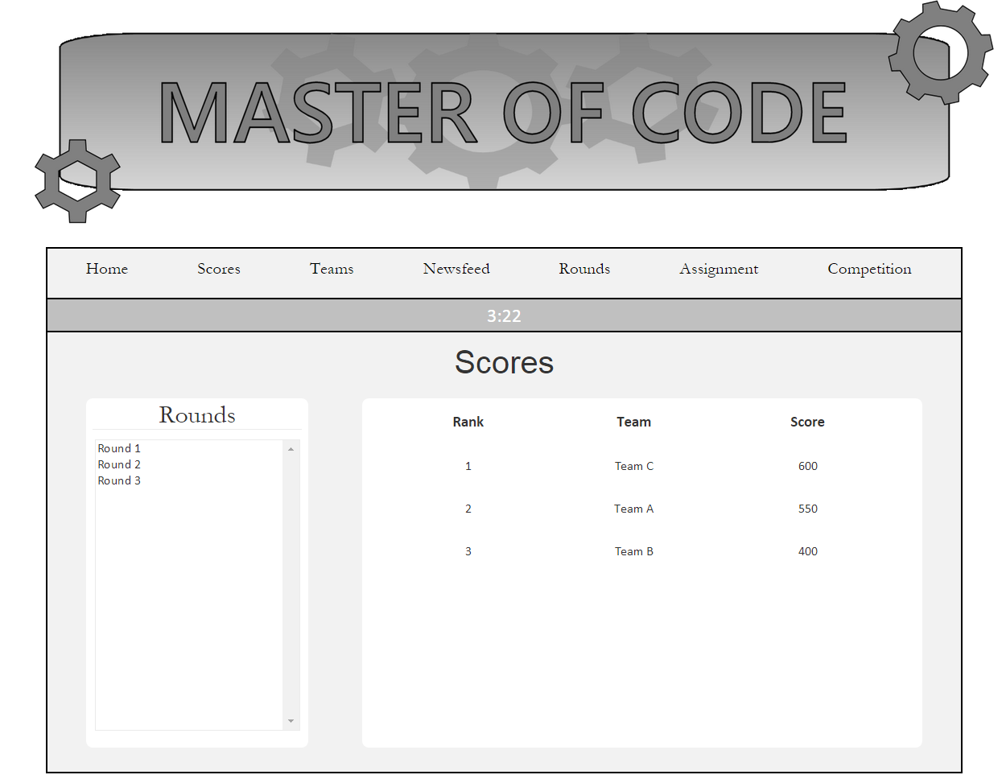

## Teams

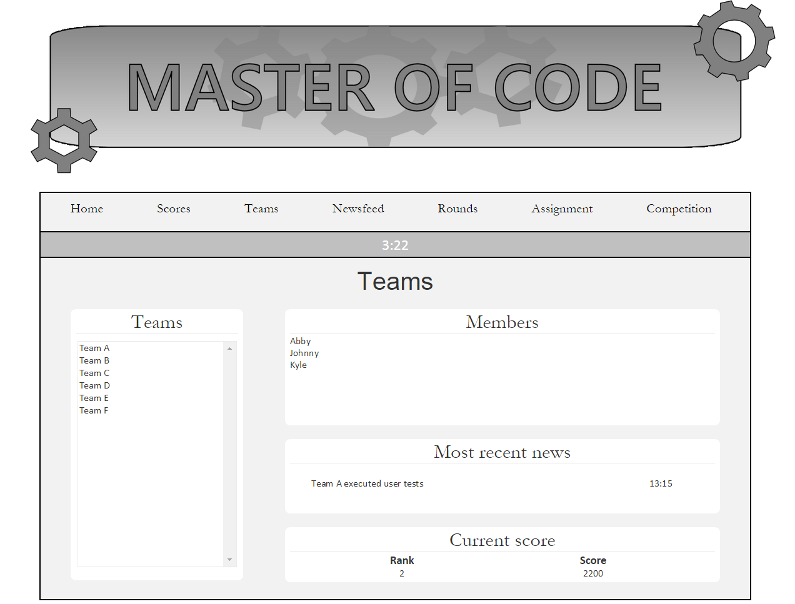

## Newsfeed

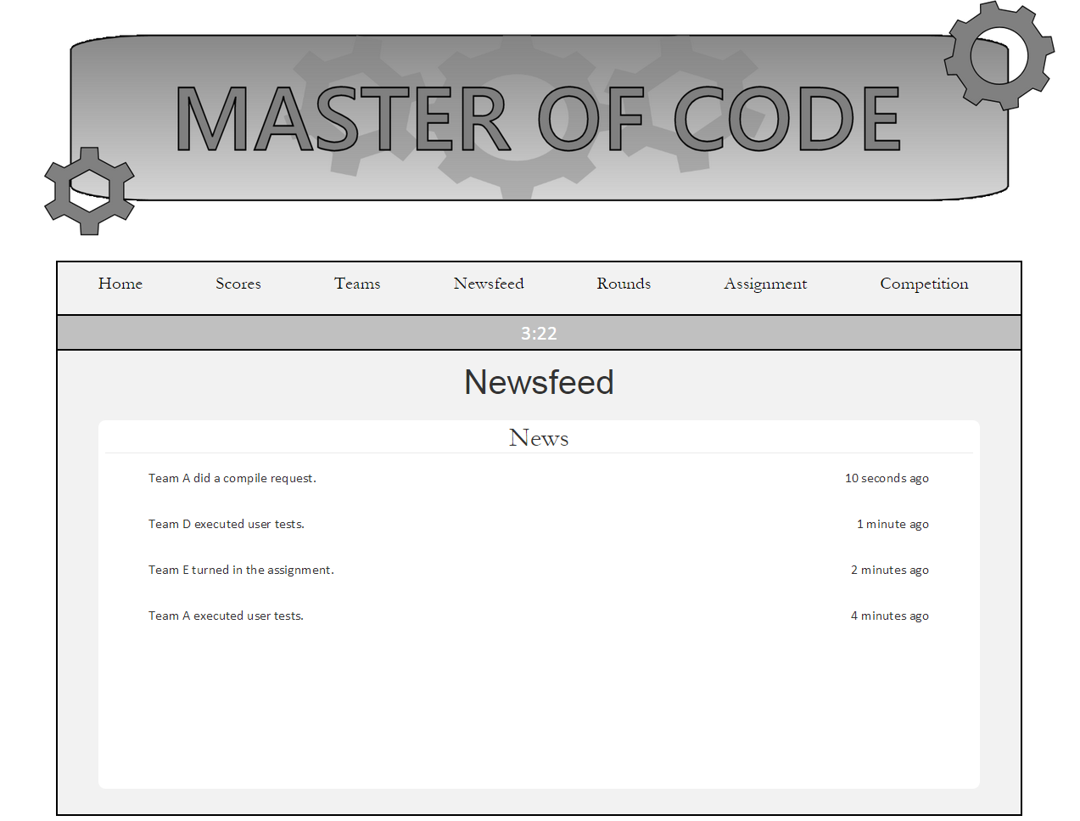

## Rounds

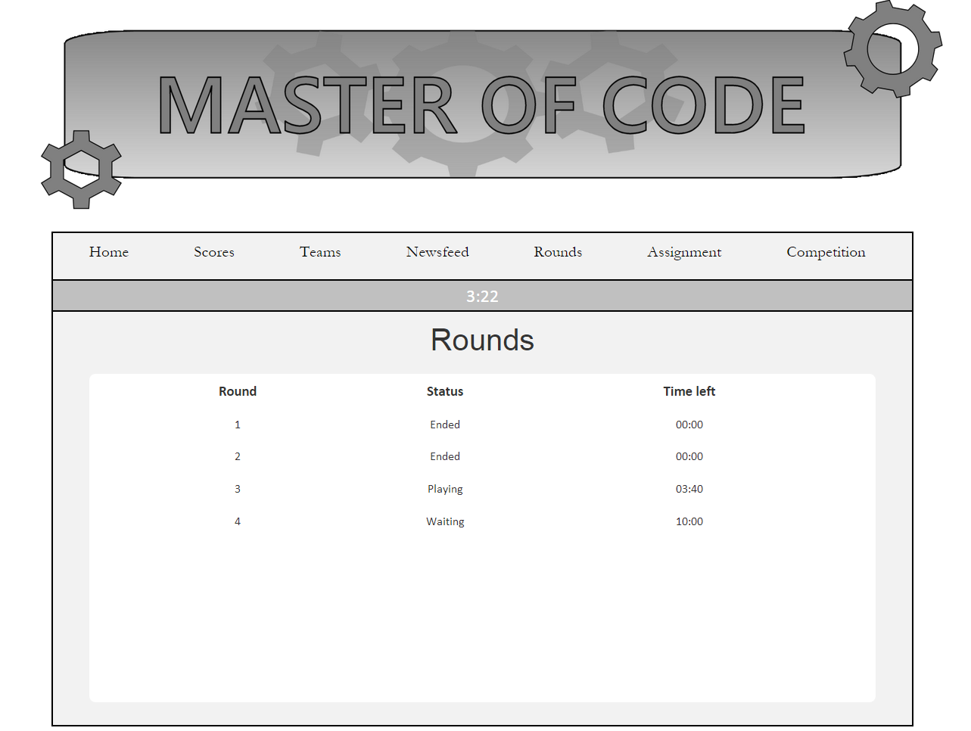

## Assignment

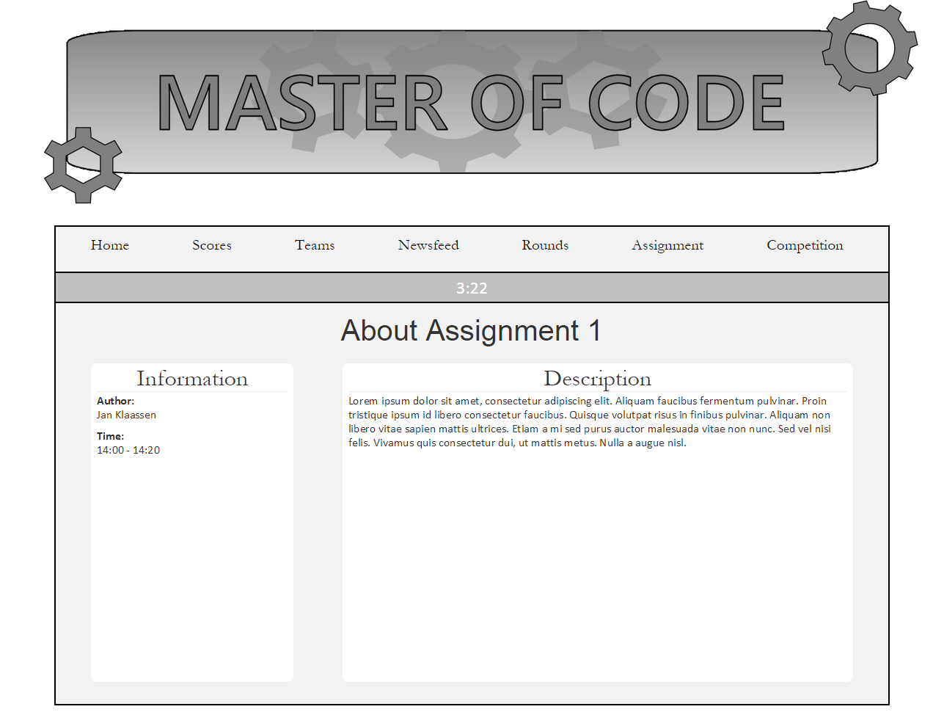

Competition

